Overview

Additional billing related information has been provided to IEE such as Rate Category and Portion for GSD_1120 and GSD_1130 customers. This information are stored in UDAs (User Defined Attributes), which are available in the Validation Queue. This will help SEOC operators to prioritize solving/isolating the validation queue exceptions for the applicable GSD customers.

Business Process Procedure Overview
Overview of changes to IEE screens on new UDA fields

- Rate Category and Portion are now stored in IEE
- Rate Category and Portion have been added as searcheable attributes to the Validation Queue

New UDA Fields

Rate Category and Portion are being sent to IEE as UDA fields during the AMI Meter Synch process.

Rate Category and Portion are stored in IEE linked to the Service Point.

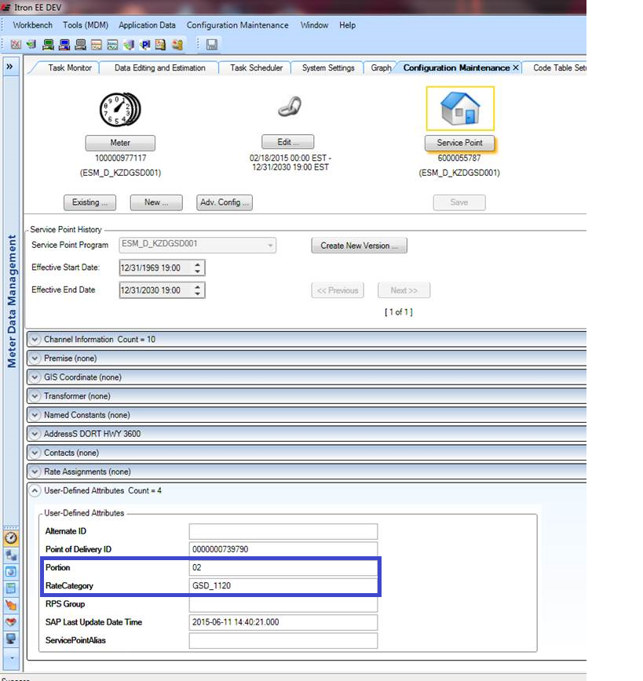

New Searcheable Attributes

Rate Category and Portion has been added as searcheable attributes in the IEE’s Validation Queue. This will aid SEOC folks in their prioritization.

